Stone Mountain Inn
(click hotel name to view hotel’s website)

1058 Robert E Lee Drive
Stone Mountain, GA 30083
1-888-670-2250 (Reservations)
1-770-469-3311 (Front Desk)

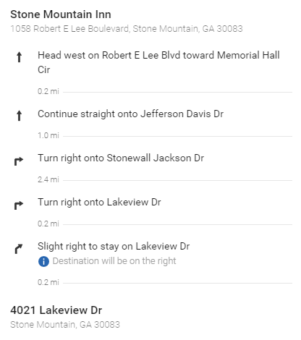
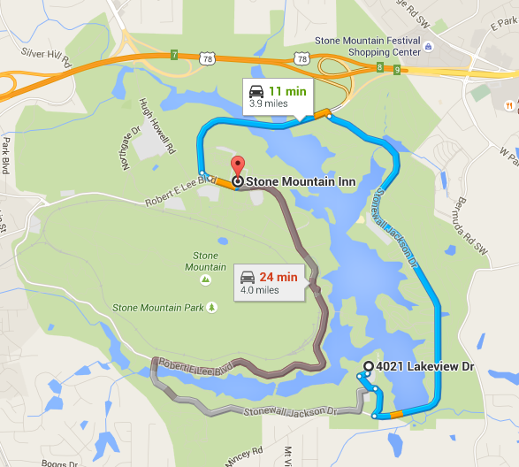
Holiday Inn Express Stone Mountain
(click hotel name to view hotel’s website)

1790 E. Park Place Blvd
Stone Mountain, GA 30087
1-800-315-2621 (Reservations)
1-770-465-8847 (Front Desk)
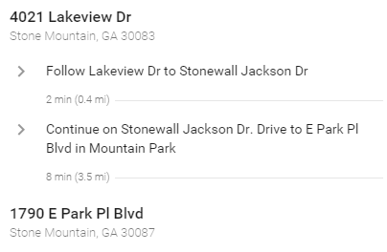

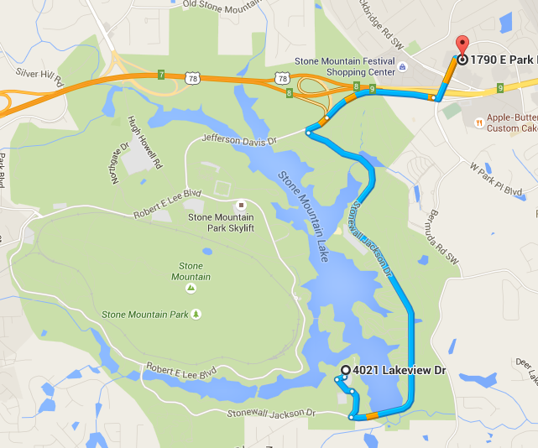

Country Inn & Suites
(click hotel name to view hotel’s website)

1852 Rockbridge Road
Stone Mountain, GA 30087
1-800-830-5222 (Reservations)
1-770-465-6515 (Front Desk)

