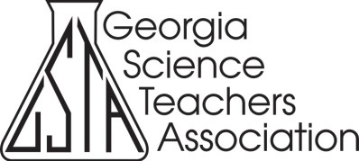
Connect With and Support
Georgia’s Science Teachers

2019 Conference Program Advertising Information
GSTA’s 2019 annual conference is expected to bring more than 1,300 K-16 science teachers and science supervisors to Columbus for 2½ days of professional learning, networking, collaboration, and recognition. Would you like to share your products and services with these educators by advertising in the conference program and app? If so, then please complete the information below

(Please check your preference)

FULL PAGE COLOR, INSIDE FRONT COVER $1,000

FULL PAGE COLOR, INSIDE BACK COVER $1,000

FULL PAGE BLACK & WHITE | $ | 750
HALF PAGE BLACK & WHITE | $ | 500
QUARTER PAGE BLACK & WHITE | $ | 250

Company Name | Company Contact

Address

Phone Number | Fax

Email Address

One full-page size advertisement is 8.5” x 11”. Rates are for camera-ready copy. Vertical ads are recommended. Advertisements are limited to pages described above and will be accepted on a first- come basis.

Please contact Donald White, Conference Chair to place your program advertisement
(donald.white@cowetaschools.net).

